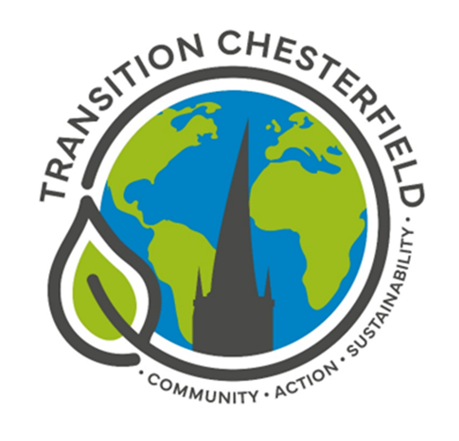

Transition Chesterfield is a local community group making Chesterfield more resilient and sustainable.
Our aim is to create positive local solutions to the challenge of climate change.

MEMBERSHIP APPLICATION

Name

Address

Telephone

Email

Next of kin | In case of emergency, please provide a contact name & number
Signature  and  date | I agree with the aim of Transition Chesterfield  and give consent for my personal details to be held by Transition Chesterfield.

Privacy notice: Transition Chesterfield (TC) is a non-profit voluntary organisation. We hold your details for the purpose of informing you of our activities and events. We do not share your details with anyone else and will never pass them on to anyone else without your explicit consent. We will hold these details until you inform us that you no longer wish to be a member.

Please hand this form in to a member of the committee
or scan and return to membership@transitionchesterfield.org.uk

